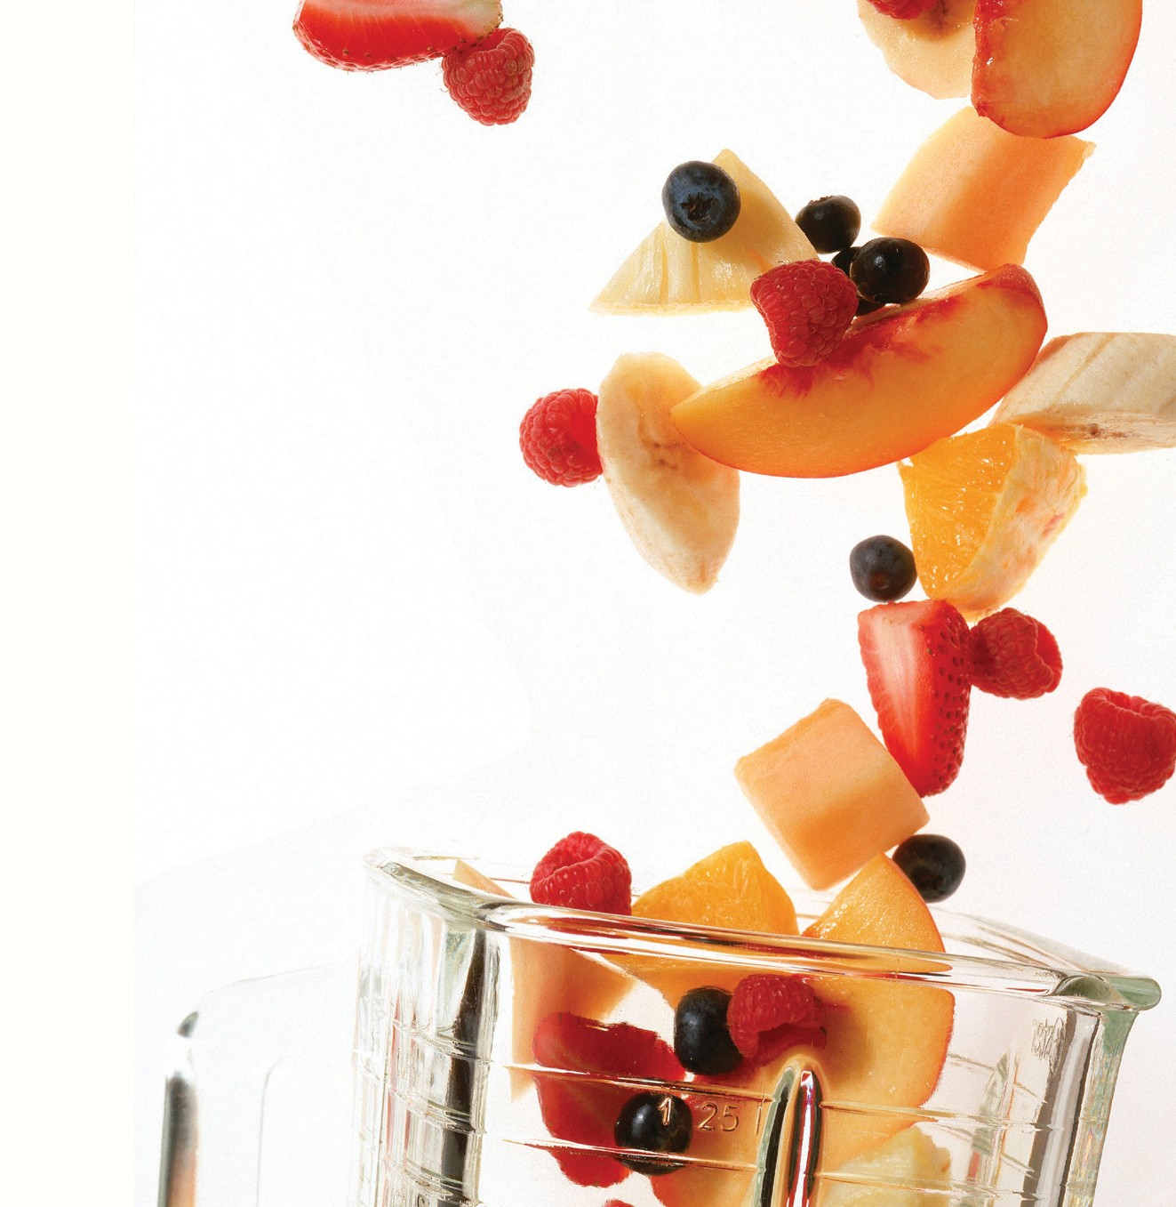

LET’S CELEBRATE OUR TEAM WITH A SMOOTHIE SOCIAL!
Time to gather all the fresh goodness of the season and get together for a fun and refreshing Smoothie Social!
Mark your calendar for [INSERT DATE and TIME]. Blenders and ice will be on hand. All you need to bring are one or two ingredients from the sign-up sheet we will post in advance of the event.
Or bring the ingredients for your own favorite smoothie and take part in our recipe challenge! We will be voting on who whirls up the tastiest AND healthiest smoothie.
To help improve your chances of winning, here are some quick Healthy Tips (including ways to “go green” beyond kale and spinach).
Let’s celebrate our team!

If you have any dietary restrictions or food allergies, please contact [INSERT NAME] at [INSERT PHONE OR EMAIL].

©2016 Kaiser Foundation Health Plan, Inc.

